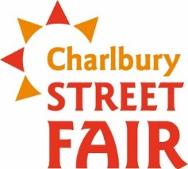
Charlbury Street Fair 2020

First Annual Superhero (Scarecrow) Competition
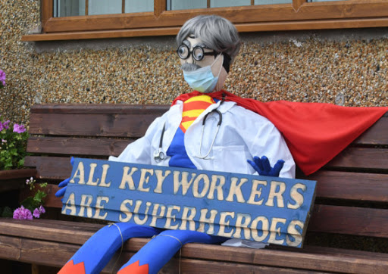
Display from Friday 28th August to Sunday 20th of September

So, thinking Caps on, Prize for the best.

Everyone can take Part

Use your Christmas tree brackets. Use windows if they look onto streets

Judging will take place before Street Fair and Winner will be informed on Street Fair Day

Please enter by 10th August. £2 to enter. All money raised goes to the Corner House and Memorial Hall.

Please email csfsuperhero2020@gmail.com to enter

