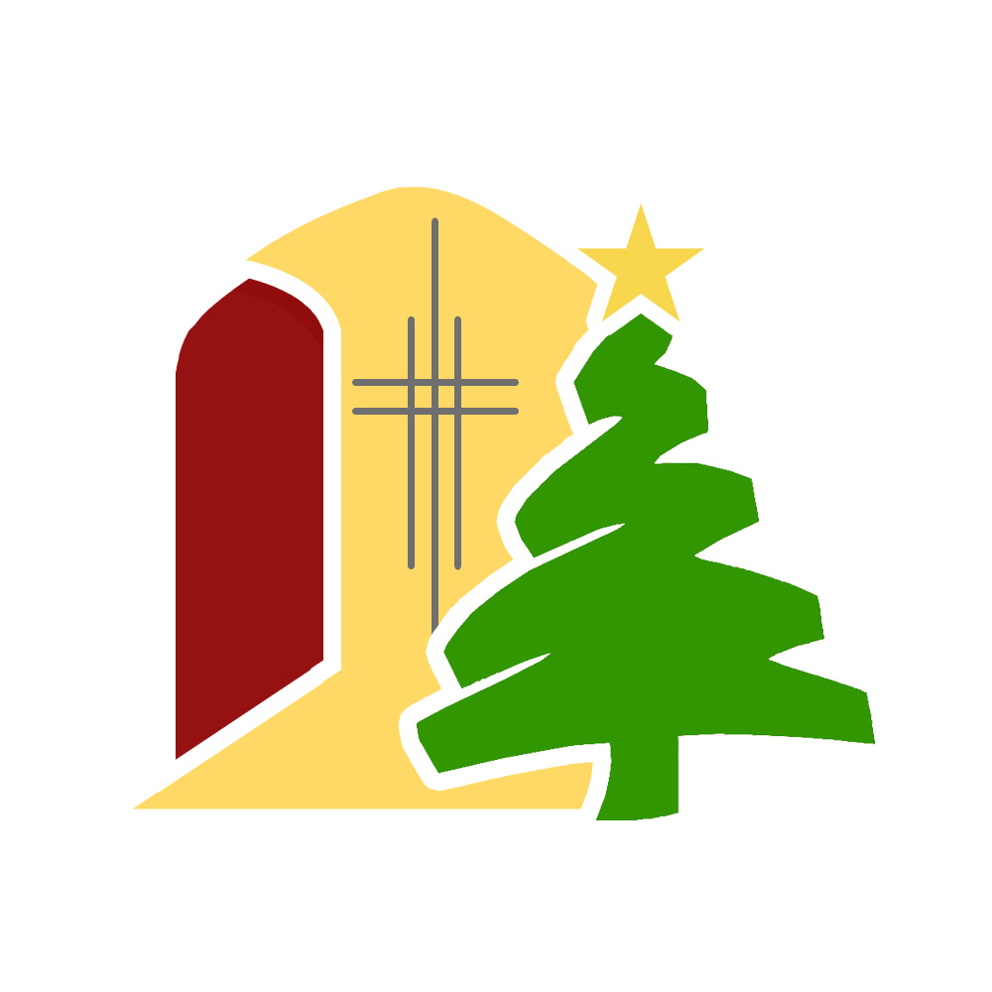ST MARY’S CHURCH CHARLBURY
CHRISTMAS TREE FESTIVAL
9th to 27th December 2021

BOOKING FORM TO PURCHASE AND DECORATE A TREE

Name of organisation ...............................................................................................................................

Contact Name ...............................................................................................................................

Email ...............................................................................................................................
Phone Number ...............................................................................................................................

We are making the Christmas Tree Festival a more sustainable event this year. Each tree will have roots and be planted in a pot. The cost per tree is therefore slightly higher this year – £35.

The trees will be decorated on Wednesday 8th December between 1030 and 1800. Please confirm the approximate time you’d like to decorate your tree. Decorations can be taken down on 27th or 28th December. We will dispose of any decorations still up after that. The trees will be recycled.

I will decorate my tree on Wednesday 8th December at …………………………………………
I will take down my decorations by 28th December YES NO
I’d like to add a donation to help pay for transportation YES NO …………………………..

ORDERING AND PAYMENT DETAILS

Please send or email (hilli.waller@gmail.com) to Hilli Waller, The Old Dairy House, Thames Street, Charlbury OX7 3QL

- Cheques made payable to Charlbury PCC to the above address
- Online payments
- Payee: Charlbury PCC Sort Code: 40-52-40 Account: 00032374
- Reference: CTF & Name of Organisation
- Any queries to the Treasurer, Peter Durrant treasurer@stmaryscharlbury.co.uk

Email confirmation will be sent on receipt of your application with payment.
There will be 50 trees, allocated on a first-come-first-served basis once payment has been paid.
As it was such a success last year, trees will be placed outside, along the churchyard path, except for the children’s trees, which will be inside the church. This gives the children’s groups more opportunity to make different types of decorations, which can remain dry inside.
Competition sheets will be available inside the church during the first four days.
The results will be announced on Sunday 11th December at the evening event. There will also be a number of other events over the first weekend. More information will be available soon.

Please encourage all your friends and Charlbury groups you know to get involved!
We hope you’ll enjoy taking part in this year’s Christmas Tree Festival.
Thank you very much for supporting your local church, St Mary’s Charlbury.

