DEEP RELAXATION
&
YOGA NIDRA
Join us for a workshop of deep relaxation for the mind and body. Experience Yoga Nidra which is an ancient practice where you are guided to a state of consciousness between being awake and asleep.
.
Saturday 21st January
4.30pm – 6pm
At
The Friends Meeting House, Charlbury
Also on line via zoom
Led by Nikki Jackson, yoga therapist and yoga teacher who has taught this specialised practice of Yoga Nidra as well as deep relaxations for over 30 years
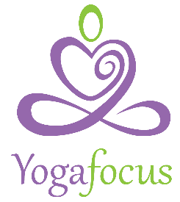
To Book contact:
Nikki Jackson
Nikki@yogafocus.co.uk
www.yogafocus.co.uk

