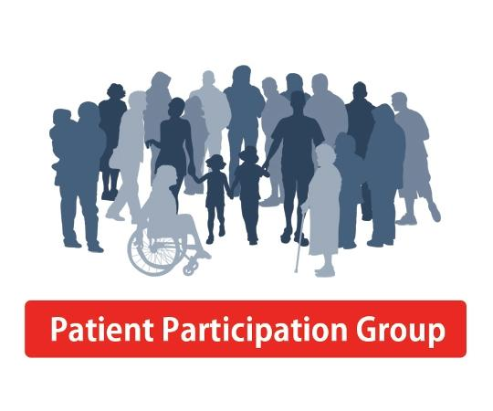
Patients of Charlbury Medical Practice

What’s Changing in Charlbury Medical Practice
Find out more on:
Wednesday 24 July
6:30pm
Charlbury Medical Centre
This drop in event is organised by Charlbury Patient Participation Group and Charlbury Medical Centre

