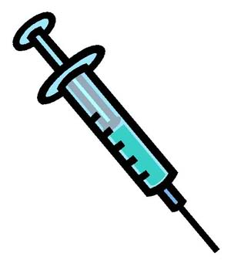
Are you entitled to a free flu jab?
Flu is not the same as getting a cold. It can seriously affect your health and the risks of developing complications are greater for people within the ‘at-risk’ groups. Healthy individuals usually recover within two to seven days, but for some the disease can lead to a stay in hospital, permanent disability or even death.

NHS flu vaccination
People 'at-risk' of flu are encouraged to have a free NHS flu vaccination. These include:
• People aged 65 years and over
• Patients aged from six months to 65 years in clinical ‘at risk’ groups
• Pregnant women
• All children aged two to ten (but not 11 years or older) on 31 August 2019
• People in long-stay residential care homes
• Carers
Flu can be serious for young children, but a simple nasal spray vaccine can help protect them. It is free, fast and painless. Children are also super-spreaders of flu; by vaccinating them it reduces the risk of spreading flu to frail and 'at-risk' groups.

Long term conditions:
The free flu vaccine is available to patients who have one of the following conditions:
- a heart problem,
- bronchitis,
- emphysema or severe asthma,
- kidney disease,
- liver disease,
- had a stroke or a transient ischaemic attack (TIA),
- diabetes,
- neurological condition e.g. multiple sclerosis (MS),
- morbid obesity (BMI over 40),
- cerebral palsy
- learning disability.
For more information on the flu vaccination visit: https://www.nhs.uk/conditions/vaccinations/flu-influenza-vaccine/
If you are entitled to a free NHS flu vaccination and haven’t already had one, please book an appointment for the vaccine.
This information comes from www.nhs.uk For more information on the flu vaccine please visit the NHS website

