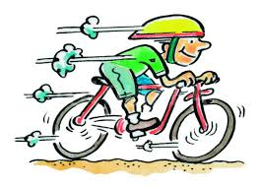
On Yer Bike – or a Scooter!
For Third Charlbury Children’s Bike Rally
round Charlbury’s five churches
11.30 am Saturday 14 September
Last year’s rally was enjoyed by some 40 children (and panting parents) despite the weather. This year it will again be organised jointly by the Oxfordshire Historic Churches Trust and the Windrush Bike Project but will also be raising money for Charlbury School and OHCT.
Balance bikes and scooters will be eligible for the youngest category. Like last year the routes will start at St Mary’s churchyard gate and end at the Windrush Bike Project tent on the Playing Close where all children who complete their route will receive certificates and prizes. Over 8s will have a longer course via Park Street, 5-Ways and Hixet Wood.
Registration from 10am. Minimum donation £3 per child on the day or, better, sign up online in advance and provide URL of online sponsorship page. See https://ohct.org.uk/ride-stride/take-part/ for details.

