Finstock Local History Society
Next event –
Friday May 20th - Cotswold Arts and Crafts and Folk Music
A talk by Martin Graebe

Late in the Victorian era, the Arts and Crafts movement and the revival of interest in folk music both looked back to the simplicity of past ways of life. The cross-currents brought a number of individuals together and this presentation describes how villagers and the arts and crafts community sang and danced together, and how the Cotswolds led the way for the rest of England.

Martin Graebe is a researcher and writer about traditional song and song collectors. His book about the antiquarian and folk song collector Sabine Baring-Gould, published in 2017, won the Katharine Briggs Prize of the Folklore Society, and the W G Hoskins Prize of the Devon History Society.

His most recent book The Forgotten Songs of the Upper Thames, about the song collection made by Alfred Williams, was launched in October 2021. He has given talks on Baring-Gould, and on other aspects of traditional folk song, to a wide range of audiences around the world. He and his wife, Shan, perform traditional songs together in harmony. https://martinandshan.net/

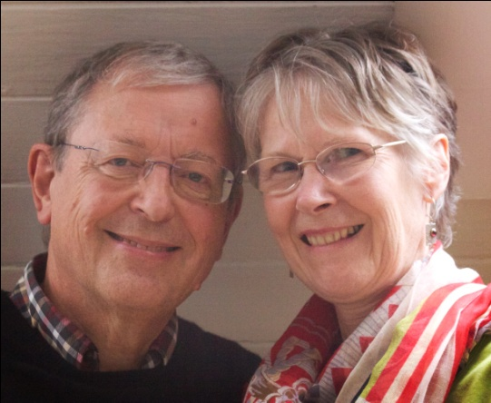

All talks begin at 8pm. Refreshments and bar open from 7.30pm.

New members welcome. Guests £2.50 each.

