A Charlbury Antiques Roadshow

Have your treasures valued by Nicholas Granger, professional auctioneer seen on Antiques Road Trip

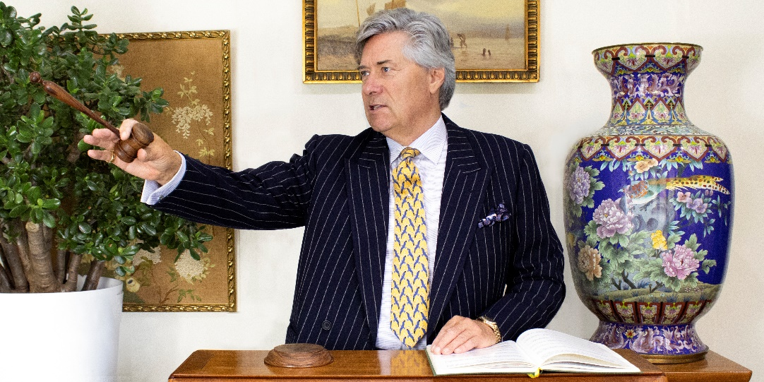

- Join us at St Mary’s on Saturday, 19 November from 1030am to 3pm to support St Mary’s and its community initiatives.

- £5 per appointment with Nicholas who specialises in jewelry, silver, watches, stamps and coins.

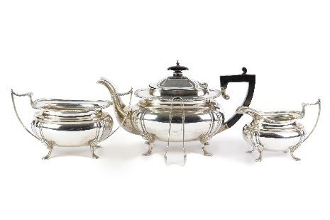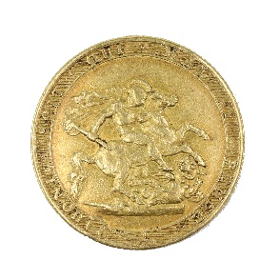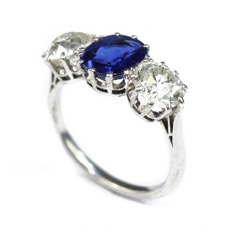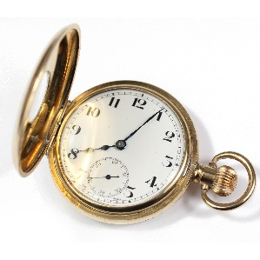

- Special commission arrangements benefitting St. Mary’s if you want to sell.

- Enjoy teas, coffees and cakes while you wait.

