Come and join us!

CHARLBURY FINSTOCK MORRIS MEN NEED YOU!
Now practising in Finstock Village Hall on Fridays at 8PM – do come along..
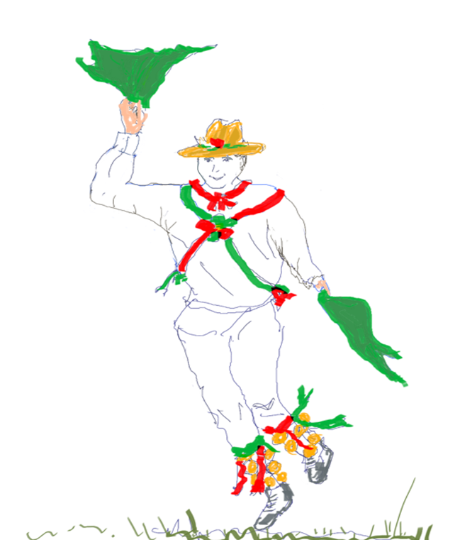
Keep fit! Entertain!

Dance! Sing!
Keep Local Traditions Alive!
Show off
Musical
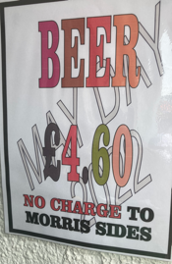
Talent!

FREE BEER (occasionally – seen at Oxford on May Morning -

Expeditions arranged – past trips included those to foreign Counties such as Devon or…. Warwickshire… and parts overseas… Belgium, Italy…
Take part in Local Events at Local Venues:
Cornbury Festival ~ Street Fair ~ Chippy Orchard ~ Combe Mill ~ Wychwood Fair
… and lots more besides!
If interested contact Peter (the Bagman) on 01608 811007 or visit our website:
info@charlburymorris.org.uk www.charlburymorris.org.uk https://www.facebook.com/charlburymorrismen

