

90th ANNIVERSARY CELEBRATION

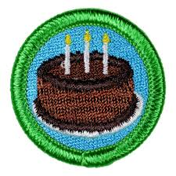

Sunday 19th November
2-5pm at the Scout Hut

All present & past Scout Group members welcome, as well as those interested in Scouting

