Morris dancing taster session
Come and give Border Morris dancing a go
We are a very friendly and relaxed group of Morris dancers dancing the traditional border style of dance with sticks and wearing rag/tatter jackets. We are looking for new dancers and musicians of all ages and abilities to join us, no previous dancing experience required. You could soon be dancing out and having fun at local fetes, fairs and festivals.
Are you thinking –
I have two left feet? I am not fit enough for that?
I have no timing or rhythm? I can’t even skip let alone dance?
That’s a lot of bearded old men drinking beer? I don’t want to go along on my own?
I don’t have the time ?

Forget all of your worries - we are a very friendly, inclusive and welcoming group of varying levels of ability. The dances are easy to learn and you can make them as energetic as you like. Some dances can even be done at a walk. We practice for one hour a week but it is not necessary to come along every week. We also enjoy some social time over a drink after practice.
We would also like to meet new musicians who enjoy playing simple traditional folk music on any kind of instrument.
Are you interested? Then why not come and give it a go, meet the team and have a cup of tea and a chat. No long term commitment is expected just come and try it.
Charlbury Memorial Hall, Browns Lane, Charlbury
Saturday 28th March 2-4.30pm
Refreshments and cake will be served
Children welcome but must be accompanied by an adult
For further information please contact Teresa on 07881 963328 / 01608 810934
Twitter: @wychwayz Facebook: Wychwayz border Morris Website: www.wychwayz.org
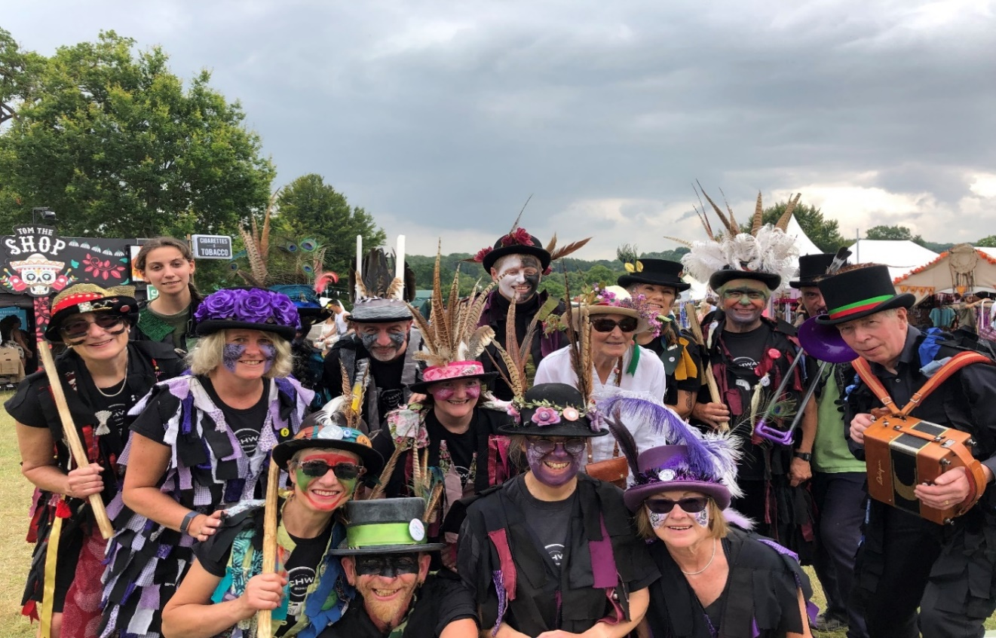
Wychwayz Border Morris at Wilderness festival 2019

